|  |  |  |  |
| --- | --- | --- | --- |
| **Campus** | **NPI** | C:\Users\dell\AppData\Local\Microsoft\Windows\INetCache\Content.MSO\C629CE2B.tmpC:\Users\dell\AppData\Local\Microsoft\Windows\INetCache\Content.MSO\CE31F471.tmp | Please Tick (✓) for  **Re-do Assignment** |
| **APU Foundation & Degree**  **Programmes** | |  |

**Coursework Submission and Feedback Form**

|  |  |  |  |  |  |
| --- | --- | --- | --- | --- | --- |
| **Name** | **Jiten Chapagain** | | | | **Name of Group Members (If Applicable)** |
| **Student No.** | **NPI000150** | | **Intake:** | **NPI1F2202IT** | Ankit Acharya(NPI000140) |
| **Module Code & Title** | **CT042-3-1( Introduction to database)** | | | | Anmol Malla(NPI000141) |
| **Assignment Title** | **UPA library management system** | | | | Satindra Bahadur Khadka(NPI000178) |
| **Name of Lecturer** | **Er.Isha Baral** | | | |  |
| **Date Due** | **2022/06/23** | **Student E-Mail: jitenchapagain2202it@infomaxcollege.edu.np** | | |  |

*I have read and understood the regulations on Plagiarism and Academic Dishonesty and declare that the work submitted does not breach those regulations.* **Signed: ________________________________**

**You must hand in to the designated APU Administrator – ensure that you receive your receipt**.

|  |  |  |  |  |  |  |  |
| --- | --- | --- | --- | --- | --- | --- | --- |
| **Received By** |  | **Signature** |  | **Date** |  | **Time** |  |

|  |  |  |  |  |  |  |  |  |  |  |  |
| --- | --- | --- | --- | --- | --- | --- | --- | --- | --- | --- | --- |
| **Criteria** | | | **Weighting** | | **Fail** | **Marginal**  **Fail** | **Pass** | | **Credit** | | **Distinction** |
|  | | |  | |  |  |  | |  | |  |
| **Additional Comments:** (These may be listed below or attached) | | | | | | | | | | | |
|  | | | | | | | | | | | |
| **Provisional Assessment Result:                                                                                          Grade            Date                Lecturer’s Initial**  C:\Users\dell\AppData\Local\Microsoft\Windows\INetCache\Content.MSO\B2A460A7.tmpC:\Users\dell\AppData\Local\Microsoft\Windows\INetCache\Content.MSO\26E1384D.tmpC:\Users\dell\AppData\Local\Microsoft\Windows\INetCache\Content.MSO\D6DB3CE3.tmp  Taking account of above factors, the overall provisional assessment of your work is: | | | | | | | | | | | |
|  | | | | | | | | | | | |
| **Distinction** | | **Credit** | | | | **Pass** | | | | | |
| **A+: 80-100%** | **A: 75-79%** | **B+: 70-74%** | | **B: 65-69%** | | **C+: 60-64%** | | **C: 55-59%** | | **C-: 50-54%** | |
| **Marginal Fail** | | **Fail** | | | | | | | | | |
| **D: 40-49%** | | **F+: 30-39%** | | | | **F: 20-29%** | | | **F-: 0-19%** | | |

*The comments and assessment result are subject to both internal and external moderation at the appropriate Examination Board.*

*Consequently, they may not reflect your final grade. You may not appeal against this result on ground of Academic Judgement.*

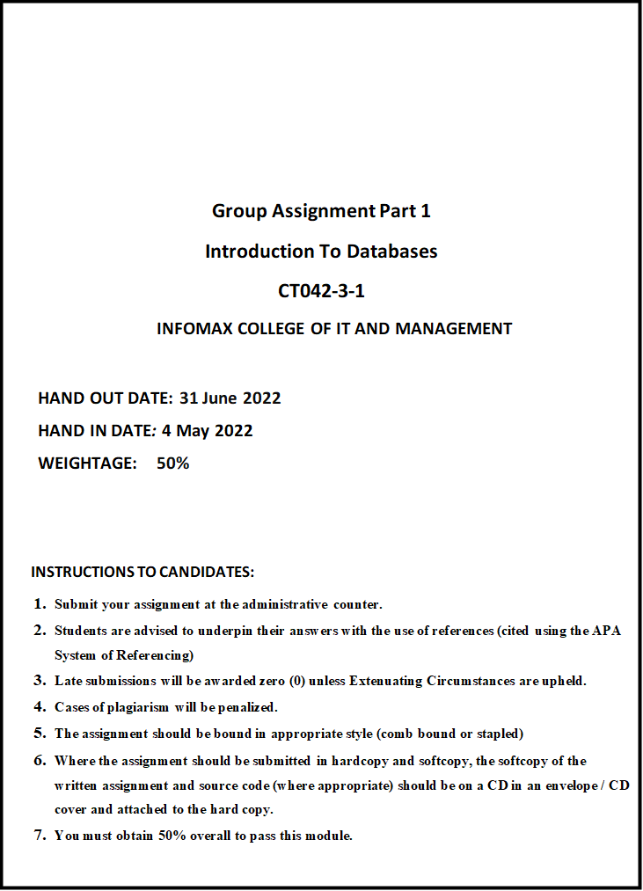

Table of Contents

Introduction 5

Acknowledgement 6

1. File based management system 7

1.1 Disadvantages of File-based Management system: 7

2. Database and DBMS (Database management system): 8

2.1 Advantage of Database and database management system 8

2.2 DATABASE MANAGEMENT SYSTEM FUNCTION:- 10

3. Relation with case study 10

4. Business rules and Normalization: 11

4.1 Business Rules 11

4.2 Normalization 12

4.3 First Normal Form (1NF) 13

4.4 Second Normal form (2NF) 14

4.5 Third normal form (3NF) 17

5. Entity Relationship Diagram (ERD) 20

Identification of entities 20

Description of each entity: 20

5.1 Identifying attributes of entities 21

5.2 Explanation of attribute of each single entities: 23

6 ER-Diagram 26

6.1 Relation between entities identification 27

One to many (1:M) 27

Many to one (M: 1) 27

Many - Many (M: M) 28

7 Constraint 29

8 Finalized ERD 30

9 Database diagram from DBMS 31

10 Reference 32

Team members:

|  |  |  |
| --- | --- | --- |
| TEAM MEMEBERS | STUDENT NUMBER | Signature |
| JITEN CHAPAGAIN | NPI000150 | Jiten |
| ANKIT ACHARYA | NPI000140 | Ankit |
| ANMOL MALL | NPI000141 | Anmol |
| SATINDRA BAHADUR KHADKA | NPI000178 | Satindra |

# Introduction

As per the request from UPA University, this system was made. This system's main purpose is to design a database model, implement that model according to the requirement and document the database system for UPA University Library Management system. The old system was a file-based system so it was necessary to use this system to solve the various business problems. This system was successfully created with a lot of group effort and research. This system consists of documentation of research of different fields in respective manner: Business rules required in library, listing required entity and attributes as well the relations between entities, this ER diagram followed by normalization and finalized ERD (Entity Relationship Diagram) diagram. Finally, database schema as well as different tables were created using MySQL.

# Acknowledgement

For providing us this grand opportunity of implementing the knowledge learned from class into a small project, our group would like to give our sincere respect to APU family, Infomax family as well as our subject teacher Ms. Isha Baral. The completion of our project was only possible due to the terrific way of teaching, proper guidelines for project-related ideas and giving meaningful theory with a notable example from Ms. Isha Baral.

# File based management system

File-based system is a technique used by the system to data in a medium. By using this we do not have to follow old methods of writing and managing paper and documents.   
Although File based system have many drawbacks.

## Disadvantages of File-based Management system:

1. **Accessibility**: Although file-based systems are made more reliable than the traditional way it can be easily accessed by anyone anywhere. Due to being easily accessible it is hard to secure the data. Like if we keep important information about the library and form file base system it insecure and anyone can access the data that we have kept.
2. **Data duplication**: There is always a high chance of duplication. Due to data that can be stored in more than 1 place. It causes duplication and is difficult to correct. Whereas, if write one information of one person in library in one file and write another information in another file then that will cause duplication of data.
3. **Atomicity**: Those files that are either incomplete or missing are Atomicity. It causes transaction failure due to incomplete files. Furthermore, we couldn’t manage to gather the information that we are searching for in library if the file is incomplete.
4. **Inconsistence**: Due to duplication located in many places that cause redundancy which led to data inconsistence. Such as if we store the information in multiple place then we may not find the data when it required.
5. **Security problem**: Anyone can access file-based system easily. To avoid security problems only authorized and limited people should be allowed to access the database. As there is no any security item to secure the data in library people can easily access the data without any hesitation even though if people are not access to the system.
6. **Limited data sharing**: Due to diverse types and formats of files and data. It is hard to share between different departments and limited in nature. As proof, in library while using file based system we keep data in different place within a different format but while sharing data within a group of people it is hard to collect all the required information for the source.

# Database and DBMS (Database management system):

Database is the set of data and information which is stored in various server -type data storage. All Database have multiple table which contain many related and several different fields. We can take a company database which may include tables for products, financial records, employees, etc. as an example of Database.

Database management systems are the collection of programs or software which enables the user to make, maintain as well as use of Database.   
 

* 1. Advantage of Database and database management system

1. **Reduce Data redundancy**: The record-based information management framework contained many records located in many different areas, either within one framework or even between different frameworks. This could result in different duplicates of the same dataset, resulting in repeated information. This is a single database and any changes will be reflected immediately, so it is expected in the database. Therefore, there is no way to learn how to copy information. For example, if we keep the data of library in multiple place and at the time of changing data then we can easily access the data and change the data.
2. **Data sharing**: Databases permit database clients to share information between themselves. Like it gives the people of library to create variety of information from data they have taken and also permit distributing the data among themselves who have access to the system of library.
3. **Privacy**: It secure the data and make privacy in the particular field by not allowing the other user to access the database. Only the accessible person have right to access the database and access the information. In library, only the librarian have right to access the data that is relate to their sector.
4. **Backup and recovery**: It help to recover the existing data which was available in past. Furthermore, it help to secure the data for future use. Whereas, in library we can collect the information of the person what they are reading and what type of book category member is using.
5. **Data consistency**: It refers to, if the data of same place or different match or not to its defining data type. For example, the name of books must be in character and its price must be in integer.
6. **Data Integrity**: Information astuteness implies that the information is precise and reliable within the database. Information Judgment is exceptionally imperative as there are different databases in a DBMS. All these databases contain information that is obvious to different clients. So, it is vital to guarantee that the information is correct and steady in all the databases and for all the clients.

## DATABASE MANAGEMENT SYSTEM FUNCTION:-

1. **Data storage management**: It creates meaningful set of structure required for the purpose of storing the data in complicated way. It decreases the workload of user for deferent physical aspect of data storing process.
2. **Security and management**: DBMS is more secure. It helps in Data security and its privacy with management facility.
3. **Data dictionary management**: It stores the data entity and their relationship. Those types of data are known as metadata. Metadata include data type’s relation between data integrity constraints. DBMS do data abstract and remove data dependency.
4. **Backup and recovery**: In case of data lose DBMS provides utilities which allow DIM which check daily routine and special backups and do restores.
5. **Multiuse access control**: At the same time it allows group of user to access the data base without delaying or any type of data error. Therefore it ensure data constancy and integrity.
6. **Management of data integrity**: The DBMS recommends and encourage the different rules for maximizing integrity and decreasing data redundant.
7. **Data transform and Presentation**: DBMS always supports data that are independent. DBMS logically requests with the help of commands that are physically located and retrieve those data.
8. **Database communication interface**: With the help of the network anyone can access the database. It is easier while doing communication between user's points.

# Relation with case study

As the UPA library was based on file-based management system, the problems in the management was increasing day by day. With the drawbacks of file-based system, it was impossible to manage the data for which purpose with was stored. So, the DBMS was the comparatively better choice. As DBMS can easily manage the data which was required to search the various data of library such as details of book, author, publisher as well as members. It also solve the problem of data security. It is easy to use and doesn't required as many human resources as managing the data in file-based management system. It is also easy to update the data in DBMS. So, the DBMS is ultimately better choice for the UPA library than that of manually functioning File-based management system.

# Business rules and Normalization:

# **Business Rules**

Before we explain about the business rules of library, we must specify the meaning of business rules. Business rule is the rule which should be followed in the business to run the business properly without any hindrance. Setting realistic business plan, observing the primary competition, working as a team, and getting professional assistance for the future are some of the most important business rules for success etc.

The following are the business rules of the library, that our members are required to follow –

* In the library, there should be absolute silence.
* After reading, the members are required to place the book exactly where they found it.
* There is no limit on the number of books a person can borrow.
* Borrowers are limited to a maximum of five books at a time.
* In the library, smoking, eating, and sleeping are absolutely prohibited.
* In the library, cell phones must be muted or set to vibrate. In the event of an emergency or an incoming call, the receiver or the caller must be taken outside the library.
* Students and others can join our library organization by sending an application to our email address, visiting the library to register in person, or by signing up and filling out your personal details on our website.
* You can reserve a book for the future by adding it to your reading list or by telling the librarian about the book you want to reserve, and we will reserve it for you. If the book you want is not available at the time you want it, we will try to locate another copy and let you know when it becomes available.
* While returning a book, our members must be on time, and when borrowing a book from the library, they must indicate a date for when they will return the book. Our library allows a two-day grace period after the due date; if the book is not returned by the grace period's conclusion, our members will be charged unless a compelling cause for the delay is supplied.

# **Normalization**

Normalization is the process of creating table without data redundant to make data efficient. Splitting tables into multiple ones and re-joined or linked each are involved in normalization.

According to the case of UPA library, table below is the prime example for UNF condition:-

|  |  |  |  |  |  |
| --- | --- | --- | --- | --- | --- |
| Student Name | Student_ID | Department | Department_ID | Teacher | T.phone |
| Ram | NP001 | CSIT | DP010 | Tika | 9803214565 |
| Sita | NP002 | Education | DP045 | Sona | 9866754623,  9874561230 |
| Gita | NP004 | Engineering | DP018 | Deepak | 9847678923 |
| Hari | NP003 | Economics | DP007 | Mina | 9806154321,  9876543210 |

Table 1: Un Normal Form (UNF)

From the above table we see multiple data in same row which can be known as un normalized form of table. So that, it causes data redundancy. To overcome those cause it should be further normalized.

## First Normal Form (1NF)

There are some criteria to follow to perform the first normal form, some of them are as follows:

* Rows should not be duplicated in the table.
* There should be single values in each shell.
* Group should not be repeated.

So by applying the rule of 1NF, we can illustrate the above UNF (un normal form) table into 1NF (first normal form) as below:

|  |  |  |  |  |  |
| --- | --- | --- | --- | --- | --- |
| Student Name | Student_ID | Department | Department_ID | Teacher | T.phone |
| Ram | NP001 | CSIT | DP010 | Tika | 9803214565 |
| Sita | NP002 | Education | DP045 | Sona | 9866754623 |
| Sita | NP002 | Education | DP045 | Sona | 9874561230 |
| Gita | NP004 | Engineering | DP018 | Deepak | 9847678923 |
| Hari | NP003 | Economics | DP007 | Mina | 9806154321 |
| Hari | NP003 | Economics | DP007 | Mina | 9876543210 |

Table 2: First Normal Form (1NF)

The above table has been created after applying the first normal form rule. As, we can see that the data of each row are atomic and same kind of data in each attribute. In the above table, there are two student_id with same id so we need to consider both student_id and book to identify diversely.

## Second Normal form (2NF)

The requirement for the second normal form are as follows:-

* Firstly, the table need to be in 1NF.
* Partial dependency should not be on the table.

**Partial dependency**: The dependency of non-primary key functionally on portion of single or collection of a unique key is known as partial dependency.

|  |  |  |  |  |  |
| --- | --- | --- | --- | --- | --- |
| Student Name | Student_ID | Department | Department_ID | Teacher | T.phone |
| Ram | NP001 | CSIT | DP010 | Tika | 9803214565 |
| Sita | NP002 | Education | DP045 | Sona | 9866754623 |
| Sita | NP002 | Education | DP045 | Sona | 9874561230 |
| Gita | NP004 | Engineering | DP018 | Deepak | 9847678923 |
| Hari | NP003 | Economics | DP007 | Mina | 9806154321 |
| Hari | NP003 | Economics | DP007 | Mina | 9876543210 |

Table 3.1

As we can see from the above table 3.1 which is in 1NF and to convert it into 2NF we have meet the some 2NF requirement. There is partial dependency in the above table between the non-key attributes and candidate key. In which Student_ID and department, teacher, teacher phone are partial connected with the Student_ID through Department_ID.

Conversion into 2NF

|  |  |  |  |
| --- | --- | --- | --- |
| Department | Department_ID | Teacher | T.phone |
| CSIT | DP010 | Tika | 9803214565 |
| Education | DP045 | Sona | 9866754623 |
| Education | DP045 | Sona | 9874561230 |
| Engineering | DP018 | Deepak | 9847678923 |
| Economics | DP007 | Mina | 9806154321 |
| Economics | DP007 | Mina | 9876543210 |

Table 3.2: Department information table

|  |  |
| --- | --- |
| Student Name | Student_ID |
| Ram | NP001 |
| Sita | NP002 |
| Hari | NP003 |
| Gita | NP004 |

Table 3.3: student information table

|  |  |
| --- | --- |
| Student_ID | Department_ID |
| NP001 | DP010 |
| NP002 | DP045 |
| NP003 | DP018 |
| NP004 | DP007 |

Table 3.4

## Third normal form (3NF)

The following properties should be followed to form a Third normal form of table:

* The rule of second normal form should meet by the table.
* Transitive dependencies should not exist.
* All the non-primary keys must be mutually independent.

**Transitive dependency:-** The dependency of two non-primary attribute on each other is known as transitive dependency.

|  |  |  |  |
| --- | --- | --- | --- |
| Department | Department_ID | Teacher | T.phone |
| CSIT | DP010 | Tika | 9803214565 |
| Education | DP045 | Sona | 9866754623 |
| Education | DP045 | Sona | 9874561230 |
| Engineering | DP018 | Deepak | 9847678923 |
| Economics | DP007 | Mina | 9806154321 |
| Economics | DP007 | Mina | 9876543210 |

Table 4.1

There is a transitive dependency between Department_ID and T.phone. The T.phone depends on the Department_ID. If you change the Department_ID, T.phone may also change. Therefore, the table has transitive dependencies that do not meet the third normal form condition.

Conversion into 3NF

|  |  |  |
| --- | --- | --- |
| Department | Department_ID | Teacher |
| CSIT | DP010 | Tika |
| Education | DP045 | Sona |
| Engineering | DP018 | Deepak |
| Economics | DP007 | Mina |

Table 4.2

|  |  |
| --- | --- |
| Teacher | T.phone |
| Tika | 9803214565 |
| Sona | 9866754623 |
| Deepak | 9847678923 |
| Mina | 9806154321 |

Table 4.3

|  |  |
| --- | --- |
| Student Name | Student_ID |
| Ram | NP001 |
| Sita | NP002 |
| Hari | NP003 |
| Gita | NP004 |

Table 4.4

|  |  |
| --- | --- |
| Student_ID | Department_ID |
| NP001 | DP010 |
| NP002 | DP045 |
| NP003 | DP018 |
| NP004 | DP007 |

Table 4.5

To overcome the transitive dependency and avoid data redundancies of the table 4.1, the table is normalized into third normal form. In which rules of third normal form has been applied, the table in 2NF i.e. Table 4.1 is divided and new table is formed. The new table provide information about the teacher phone number.

# Entity Relationship Diagram (ERD)

The diagram that represent the relationship between the given entities is known as Entity Relationship Diagram (ERD). There are some of the step to be followed which are required to develop Entity Relationship diagram. The steps are as follow:

Step 1: Identification of entities

Step 2: Identification of attributes of given entities

Step 3: Identification of relationship between the entities.

It will be easier for making Entity Relationship diagram, if we follow those above step.

# Identification of entities

Entities: The thing that have existence as contrasted with its attribute. The entities that are possible for the given scenario are as follow:

Entities

1. Book
2. Publisher
3. Author
4. Staff
5. Student
6. Member
7. Department
8. Reservation
9. Category
10. Bills
11. reports

# Description of each entity:

|  |  |
| --- | --- |
| **Entities** | **description** |
| Book | Every people who come to the library will have a book in his\her list. |
| Category | List the item that are available on the different basics. |
| Publisher | Every book which will be borrowed by the each and every person have information about publisher. |
| Author | Book will have another information about author. |
| Staff | All the people who manage the library. |
| Member | This particular entity hold the information about people who uses books. |
| Department | This entity related with the student from which department they are and give information about department. |
| Reservation | Provide detail about no of reserve book and reservation detail. |
| Bills | Display method of payment and total payment of person. |
| Reports | Offer information about book availability. |
| Student | No of student who borrow book. |
| Book_loan | Detail of book which are currently on loan. |

## Identifying attributes of entities

The things that describe the characteristics of each entity is known as attribute. The attribute of the above listed entities are as follow:

**Attributes**:

1. Book
2. Book_ID
3. Price
4. Title
5. Edition
6. ISBN
7. Publisher_ID
8. Author_ID
9. Book_Status
10. Category_ID
11. Subject_area
12. Published-date
13. Publisher
14. Publisher_ID
15. Name
16. Address
17. Phone
18. email
19. Author
20. Author_ID
21. Author_name
22. Author_add
23. Author_phone
24. Email
25. Staff

* Staff ID
* Staff name
* Staff address
* Staff phone
* Department_ID

1. Member

* Member ID
* Member phone
* Member address
* Member email
* Member name
* Staff_ID
* Student_ID
* No_of_book_borrow

1. Student
2. Student_ID
3. Student_name
4. Student_address
5. Department_ID
6. Phone number
7. Email
8. Reports
9. Reg.no
10. Book return_date
11. Due_date
12. Issue_date
13. Member_ID
14. Bill
15. Bill_number
16. Member_ID
17. Amount
18. Date
19. Fine
20. Reservation
21. Reservation_ID
22. Reservation_date
23. Member_Id
24. Book_ID
25. Book_status
26. Category
27. C-ID
28. C_name
29. type
30. Department
31. Department_ID
32. Name
33. Head
34. Book_loan
35. Book_ID
36. Publisher_ID
37. Member_ID
38. Lend
39. Fine

## Explanation of attribute of each single entities:

Entity:- Book

|  |  |
| --- | --- |
| **Attributes** | **explanation** |
| Book_ID | Unique primary number of book. |
| Price | Which have integer value of book. |
| Title | Provide information about book related name. |
| Edition | Have time information from book. |
| ISBN | International standard book number. |
| Author_ID | Author who has written book. |
| Staff_ID | Foreign key to connect staff and book. |
| Publisher_ID | Name of the person who publish book. |
| Subject_area | From which area the book is related. |
| C_ID | Hold category number of book. |
| Published_Date | Date of publish of book. |

Entity: Publisher

|  |  |
| --- | --- |
| **Attributes** | **description** |
| Publisher_ID | Unique primary key of the publisher. |
| Name | Name of the person who publish book. |
| Phone | It is the numeric value that provide contact detail of the publisher. |
| Publisher_address | String that hold the place that where the publisher is from. |
| Email | Electronic address to connect. |

Entity: Staff

|  |  |
| --- | --- |
| **Attributes** | **description** |
| Staff_ID | Unique primary key of staff. |
| Staff_name | Name of the person who take book and belong to staff group. |
| Staff_phone | Contact number of the staff. |
| Staff_address | Place where staff belong. |
| Department_ID | Id of the department in which staff belong. |

Entity: member

|  |  |
| --- | --- |
| **Attributes** | **description** |
| Member ID | Primary key of the member entities. |
| Name | Name of the member who borrow book. |
| Department_ID | Id of the department where member belong. |
| Type | Give information about member weather the member is staff or student. |
| No.of_book_borrow | Number of book borrowed by member of the library. |

Entity: student

Entity: Report

|  |  |
| --- | --- |
| **Attributes** | **description** |
| Student_ID | Id no of the student who borrow book form library. |
| Student_name | Name of the student who take book from library. |
| Student_phone | Contact deatail of the student. |
| Student_address | Place where student live. |
| Department_name | From which department student belongs to. |
| Member_ID | Member ID of the particular student. |

|  |  |
| --- | --- |
| **Attributes** | **description** |
| Report no | Unique report no. |
| Issue Date | Date of reservation. |
| Book_status | Status of book. |
| Reservation_no | Information of reservation. |
| Member_id | ID of the person who have issue the book. |

Entity: Bill

|  |  |
| --- | --- |
| **Attributes** | **description** |
| Bill_num | Unique primary integer values of Bill |
| Bill_date | Time when the bill have taken. |
| Fine | Amount to be paid in library for not submitting the book in time. |
| Amount | Money to be paid in fine. |
| Member_Id | Member information who have bill. |

Entity: Author

|  |  |
| --- | --- |
| **Attributes** | **description** |
| Author_ID | Identification number of author. |
| A_Name | Name of the write of the book. |
| A_Add | Address of the author. |
| A_Phone | Contact information of the author. |

Entity: Reservation

|  |  |
| --- | --- |
| **Attributes** | **description** |
| Reservation_ID | Unique primary integer values of reservation. |
| Reservation_date | Date when the particular person have reserve book. |
| Member_ID | ID of the person who reserve book. |
| Book_ID | ID of book which have been reserve by the people. |

Entity: Category

|  |  |
| --- | --- |
| **Attributes** | **description** |
| C_ID | Unique primary integer values of category. |
| C_name | Name of the category where book belong to. |
| Type | Type of category book are form. |

Entity: department

|  |  |
| --- | --- |
| **Attribute** | **description** |
| Department_ID | Integer that give identity information about department. |
| Name | Name of the department member belong. |
| Head | Head of the articular department. |

Entity: book_loan

|  |  |
| --- | --- |
| **Attribute** | **description** |
| Book_ID | Book identity number. |
| Publisher_ID | Publisher identity number. |
| Member_ID | Member identity number. |
| Lend | Date of issue from library. |
| Due | Last deadline to submit book. |
| Return | Book return date. |
| fine | Amount of money that has been paid in library due to last submission. |

.

# ER-Diagram

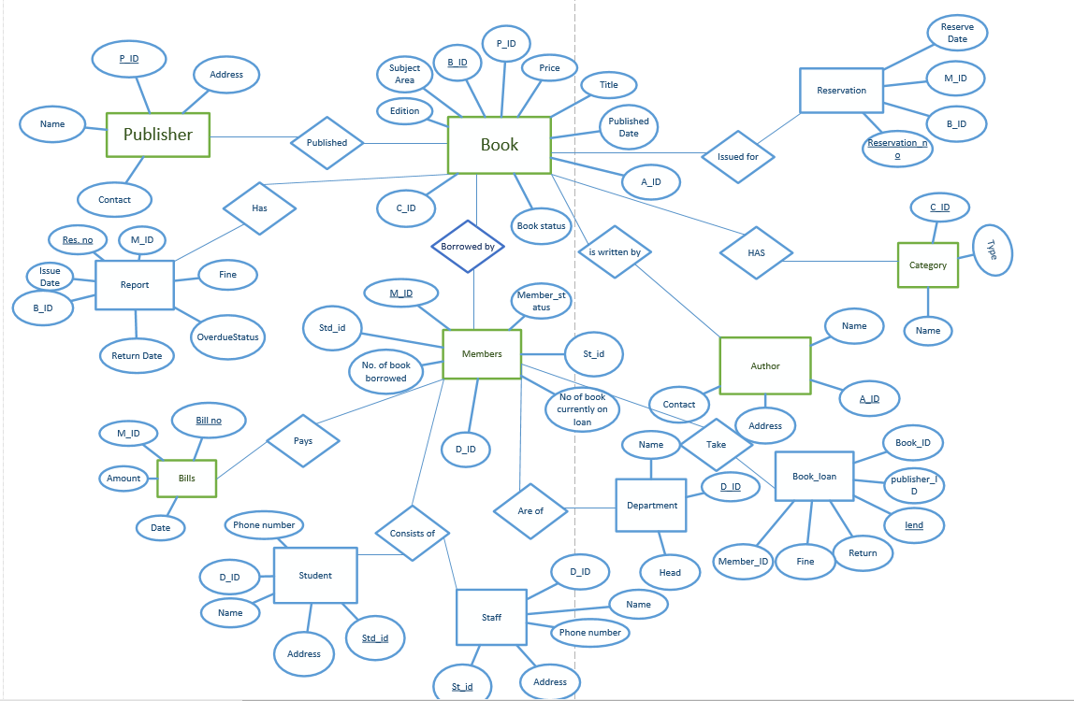

## Relation between entities identification

 To make ER-diagram firstly, we must find the relationship between set of two entities. This makes it easy to create an ER diagram. There are four main types of relationships that link entities, which are described below.

One to one (1:1)

One to one relation is the relation between the two entities in which one entity is linked with one and only one entity.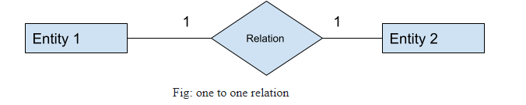

# One to many (1:M)

# 

 It the condition of relation in which one entity is associated with the many entities set.

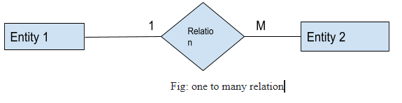

# Many to one (M: 1)

It is the condition on the relation in which many entitles are related with one and only entities in the another.

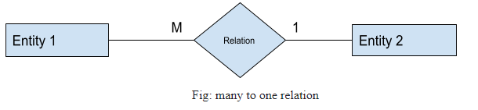

# Many - Many (M: M)

If number of entities are associated with one or more number of entities then this condition will be known as many-many relation.

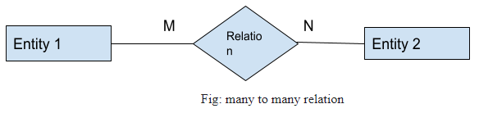

Relating to the above case (case of UPA library), following set of relation between entities are found:

|  |  |
| --- | --- |
| Relation | Explanation |
| Publisher M:N Book | In library there are many book which are published by many publisher. |
| Book 1:M Author | Many book can be written by one author, we can find the many that has been written by one author. |
| Member 1: M Book | One member can take many book from the library. |
| Book M:1 Report | Report of the all the can be written in one report. |
| Member 1:1 Bill | One member who use library pay the one bill if he/she is paying fine. |
| Member M: N Department | Many department has many staff for work. |
| Member 1:1 Student | One member can be a one student. |

# Constraint

**Logical constraints:**

1. Each student and staff can has only one member id which indicates one can create only one membership card.
2. Members can pre book the required book if the book is currently unavailable
3. Category type itself defined the book in which duration of time we can loaned for.
4. The member has to pay the extra price i.e. fine for delaying in return of the book.
5. The total no of book borrowed can defined the member as active or inactive user.

**Primary key constraints**:

1. All the primary keys are mixture of number and letters.
2. The characters consists of symbolic form of table name in letters followed by numbers.

**Default constraints**:

1. As the Over Due Status is positive or negative, fine is optional.
2. The final amount of book in bill is default as it is with the additional fine for delaying in returning.
3. The fine of different category type books varies.

**Null constraints:**

A null keyword that indicates that a column can store a null value for that data type. This means that the column does not need to receive a value during an insert or update operation. A NULL constraint is logically equivalent to omitting a NOT NULL constraint from a column definition**.**

**Unique constraint**

It makes sure that every component or values of every column is unique. Unique constraint as well as primary key makes sure to create a uniqueness for each set of column.

**NPI000150-NPI000140-NPI000141-NPI000178-DBMS GROUP COMPONENT-2**

# Finalized ERD

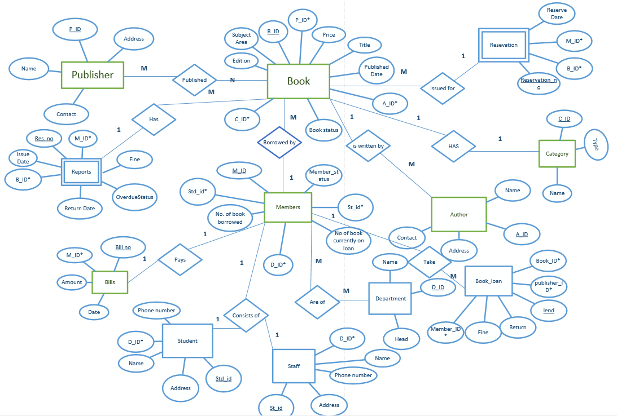

Fig 1: finalized ERD

‘*’ Denoted the foreign key in above diagram.

# Database diagram from DBMS

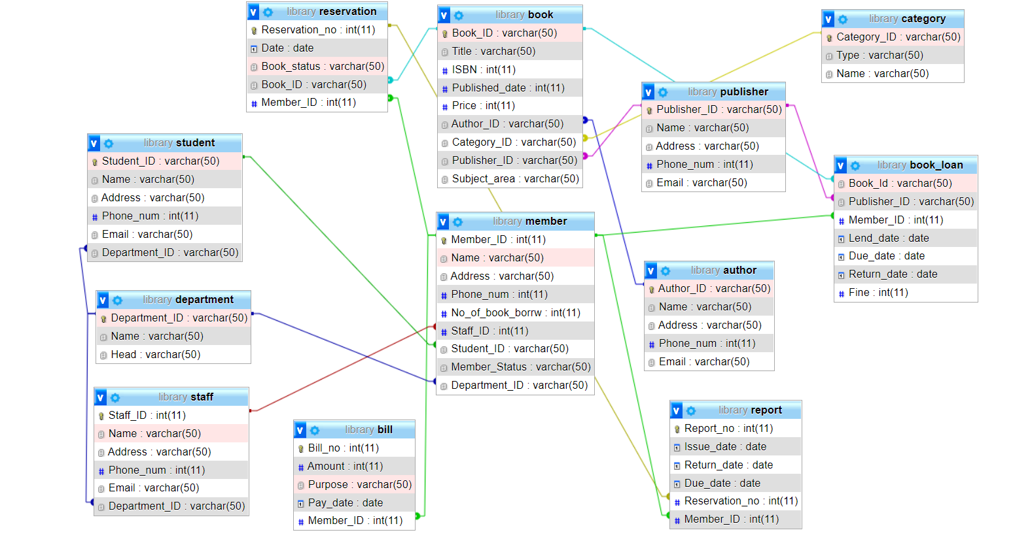

Fig 2: Data base diagram

WORKLOAD

|  |  |  |  |  |
| --- | --- | --- | --- | --- |
| **Title​** | **Anmol​** | **Ankit​** | **Jiten​** | **Satindra​** |
| Database and DBMS​ | 25​ | 25​ | 25​ | 25​ |
| Business Rule and Normalization​ | 25​ | 25​ | 25​ | 25​ |
| Entity Relationship Diagram​ | 25​ | 25​ | 25​ | 25​ |
| Database Schema​ | 25​ | 25​ | 25​ | 25​ |

# Reference

Education 4u. (2018, feb 19). Constraint in DBMS [Video]. YouTube. <https://www.youtube.com/watch?v=qOlhsLIc0lA>

Gate smashers. (2020, December 12). Structure query language [Video]. YouTube. <https://www.youtube.com/playlist?list=PLxCzCOWd7aiHqU4HKL7-SITyuSIcD93id>

Smart draw. (2018). what is ER diagram? How to make ERD? What are ERD symbols? [Video]. YouTube.

<https://youtu.be/dUJp0Yoq5eg>

Interview bit. (2022, may26). File System vs DBMS: Know the Difference.

<https://www.interviewbit.com/blog/file-system-vs-dbms/#:~:text=Advantages%20of%20File%20System,-Following%20are%20the&text=Compactness%3A%20Data%20can%20be%20stored,files%20can%20be%20easily%20edited>.

Ullman, A., & Garica.Malina, J. (2017). Data base system (second edition.).

Sibeschatz, A ,F.korth,H & Sudarshna.S (2019). Data base system concepts.(7th edition). McGraw-Hill.